**Optimization**

Optimization is the process of finding maximum and minimum values given constraints using calculus. For example, you'll be given a situation where you're asked to find: The Maximum Profit. The Minimum Travel Time. Or Possibly the Least Costly Enclosure.

1. Optimization of squared loss - The one powerline problem

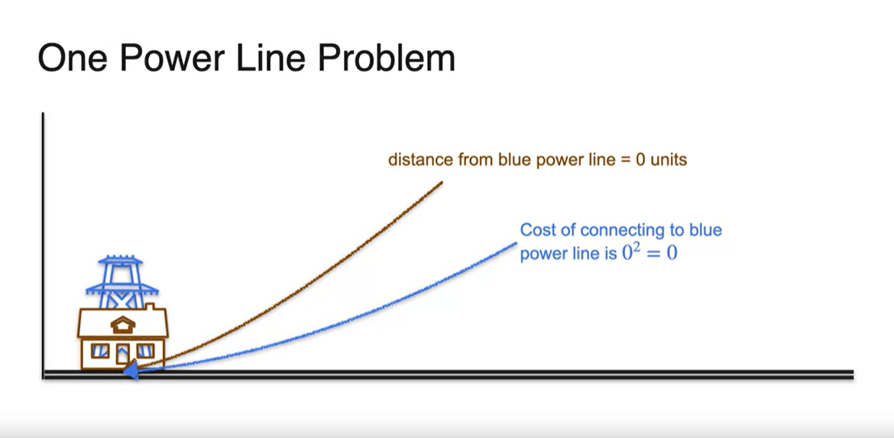

1. Optimization of squared loss - The two-powerline problem

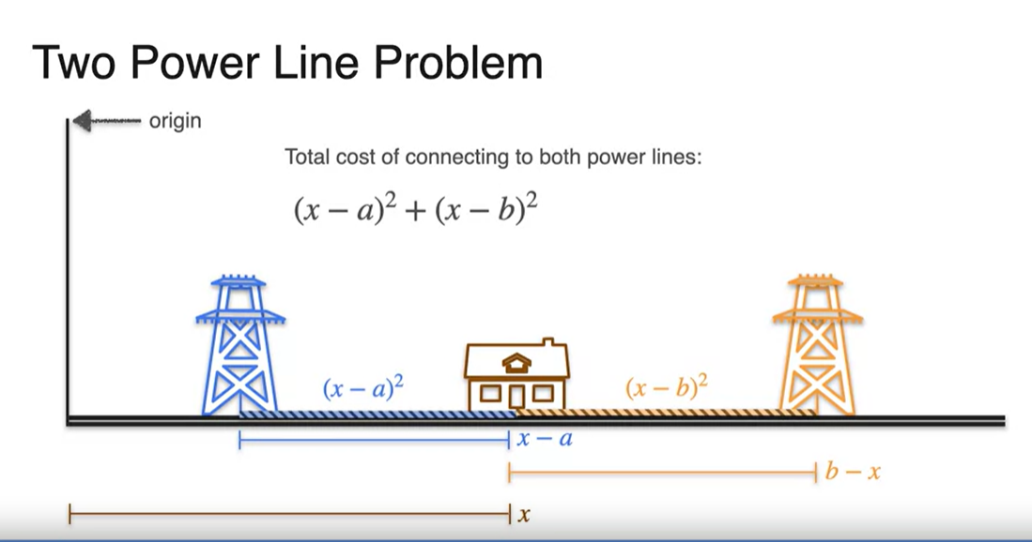

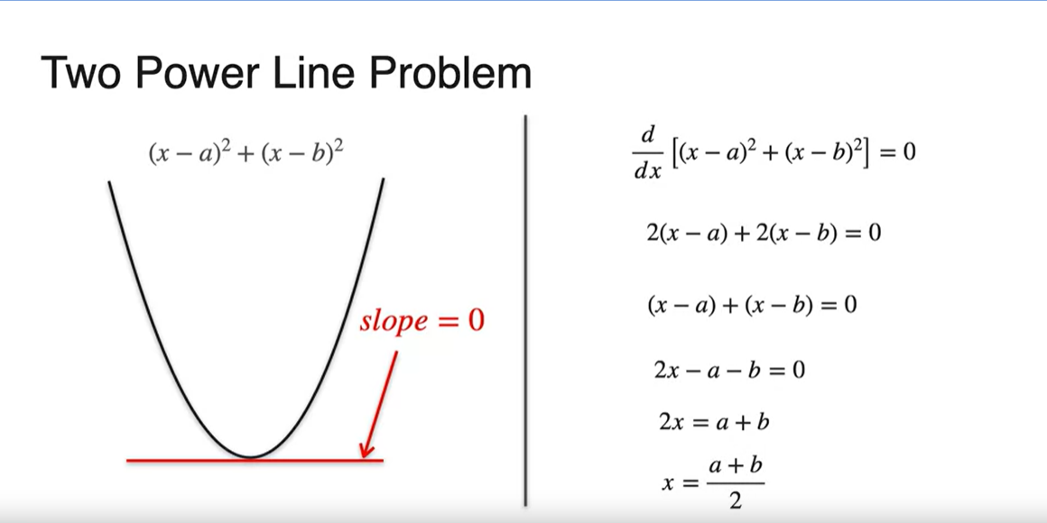

1. Optimization of squared loss - The three-powerline problem

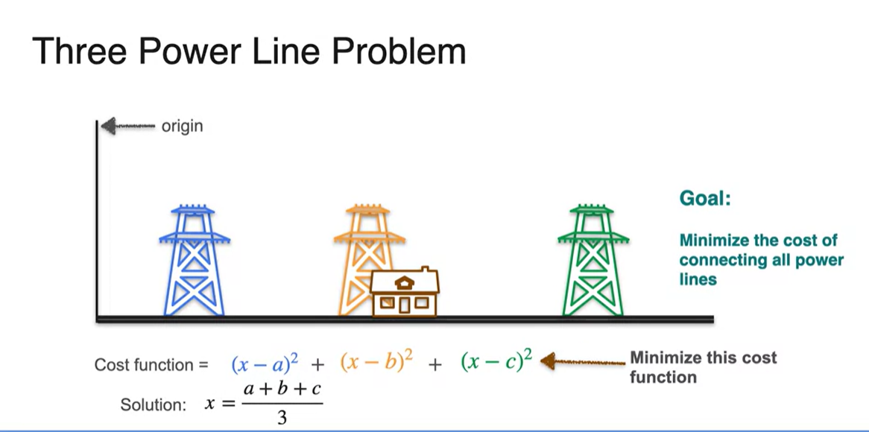

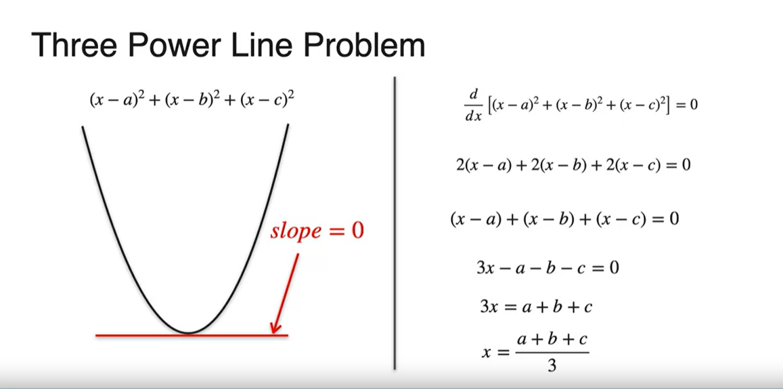

1. Optimization of log-loss

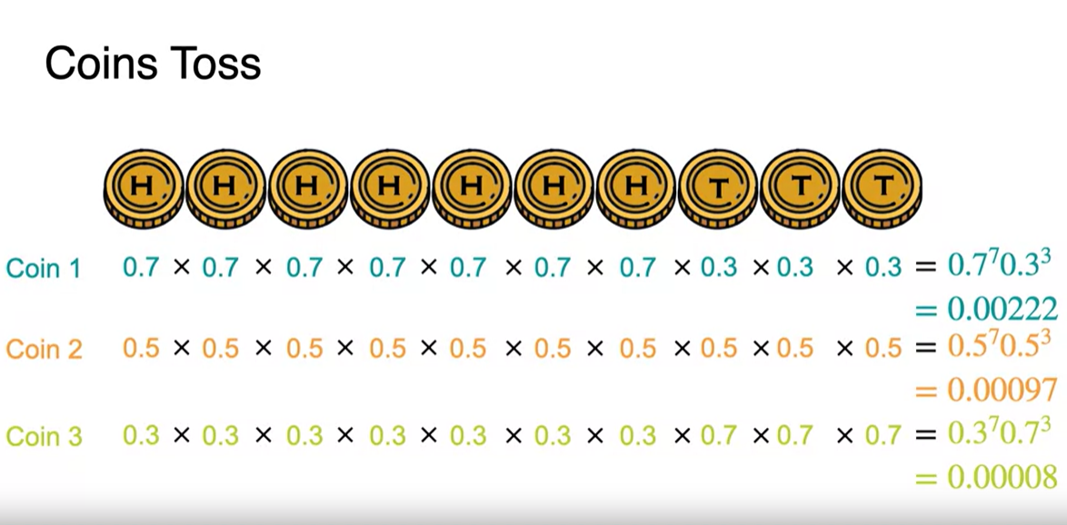

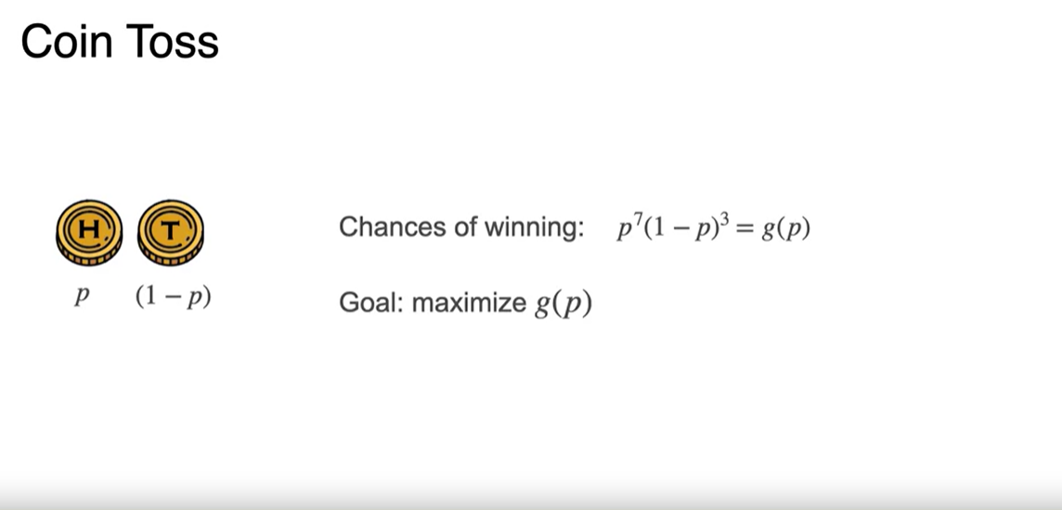

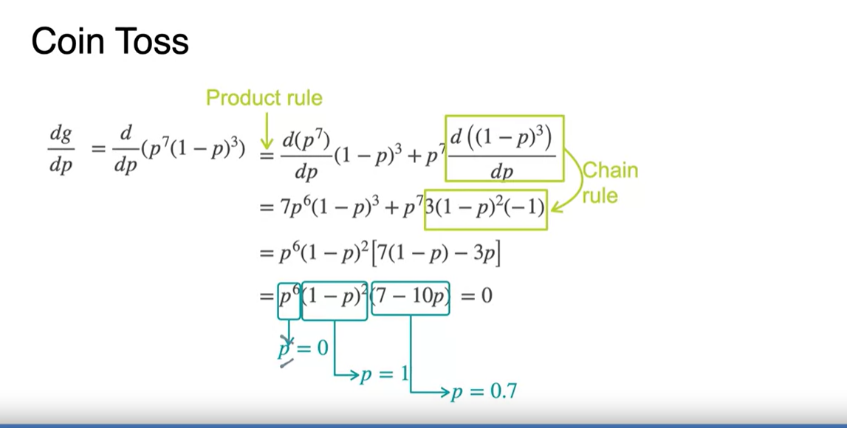

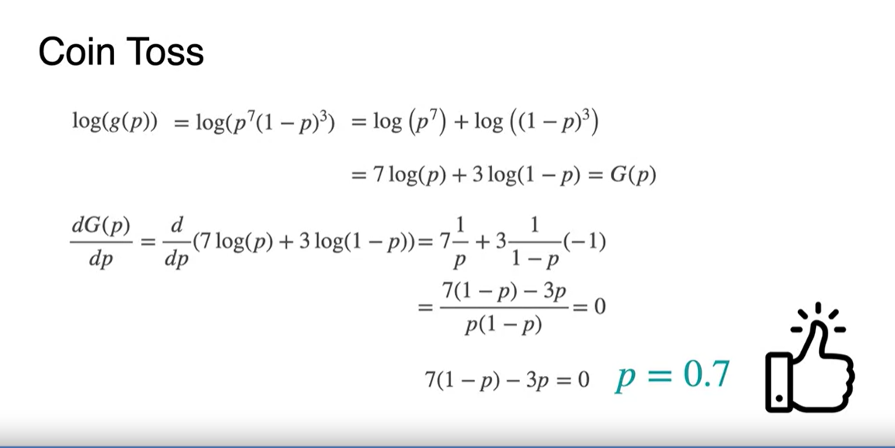

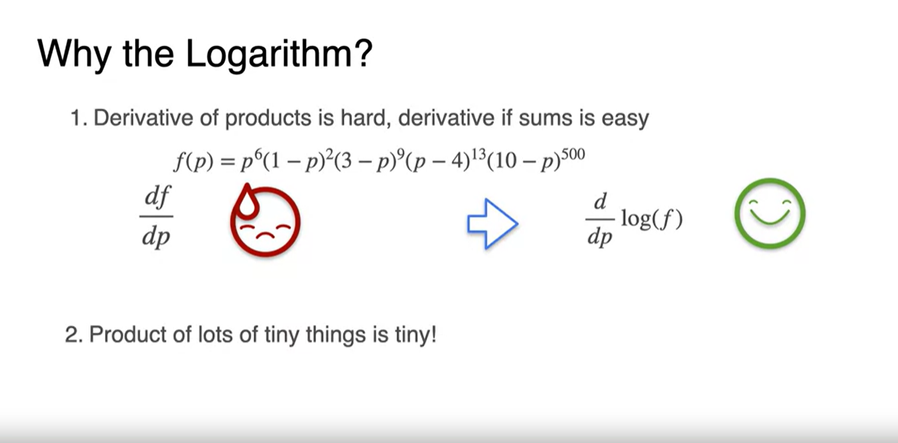

**Gradients**

1. Introduction to tangent planes

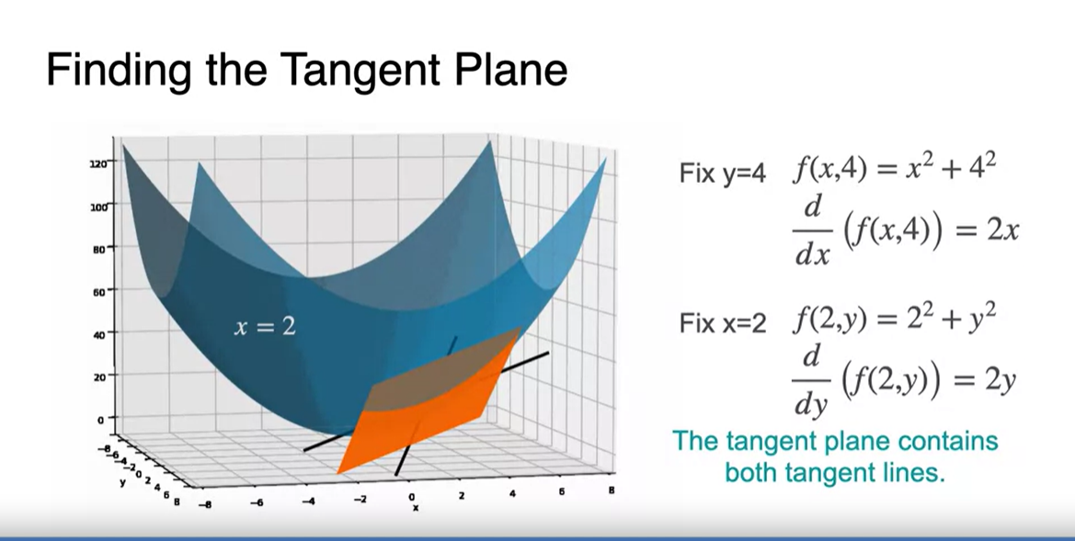

1. Partial derivatives

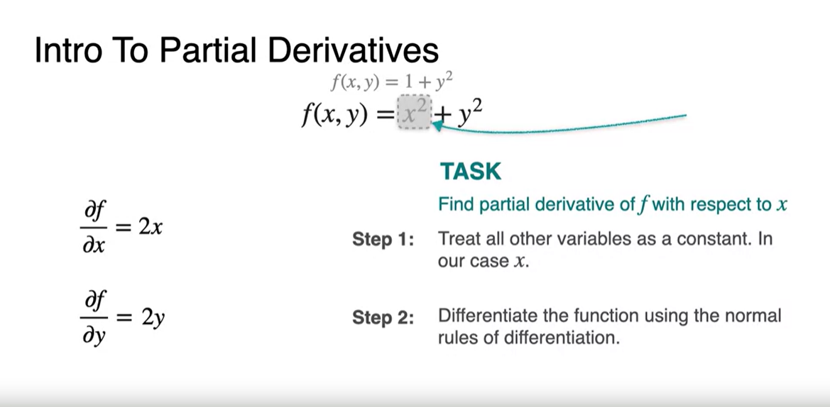

1. Gradients

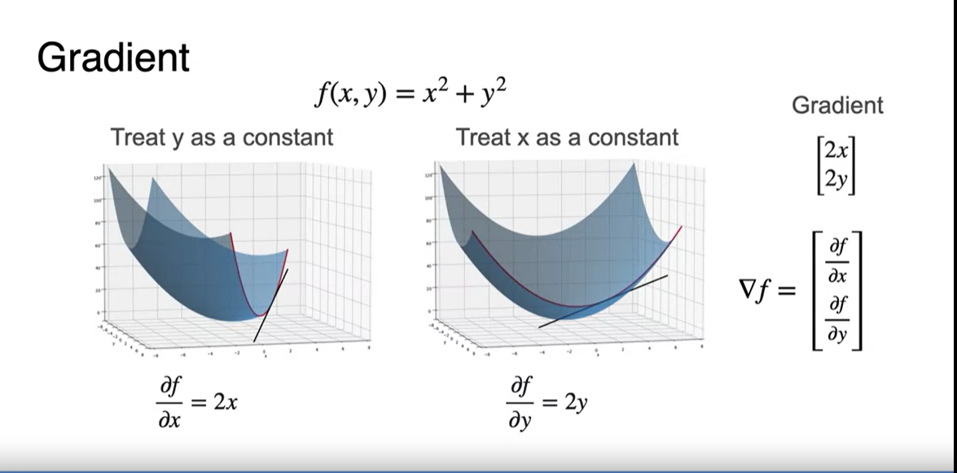

1. Gradients and maxima/minima

